**MapKit Tutorial -** Watch Podcast while following below steps

1. Create **New Single View Application**, **Product Name:** CrimeMap  
   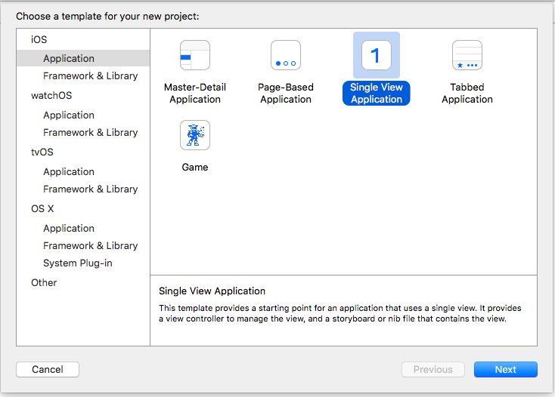  
   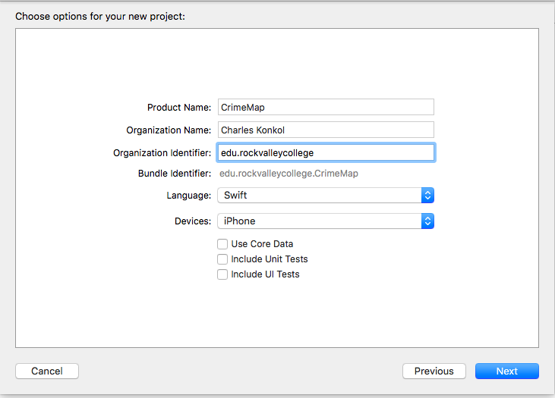
2. Set Device Orientation to **Portrait**
3. Select **Main.Stroyboard**
4. Hide Document Outline  
   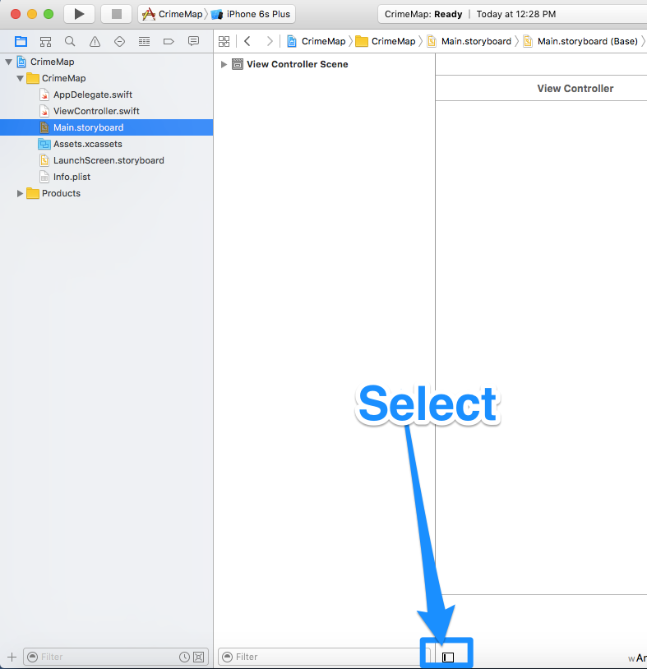
5. Add Objects to View Controller
   * Navigation Bar
   * Map Kit View
   * Label
   * UISlider  
     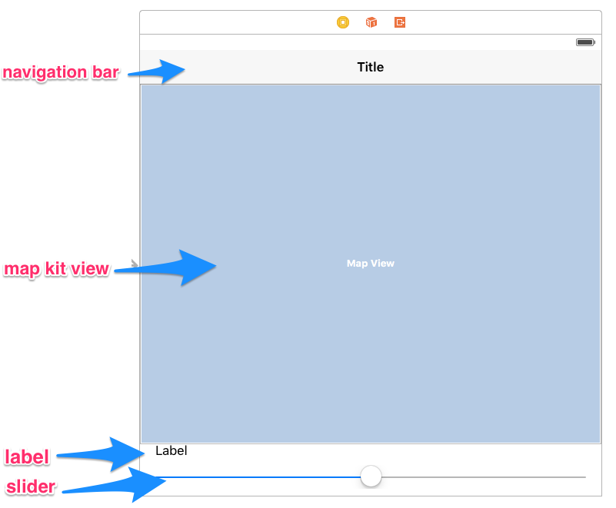
6. Click on viewcontroller.swift and add Imports to top of viewcontroller.swift

import MapKit

import Foundation

1. Click on Main.StoryBoard > Show Assistant Editor and Create Outlets & Actions (Click, Drag and Drop to Code)
   * Navigation Bar
     1. Name: navigationBar
   * Map Kit View
     1. Name: mapView
   * Label
     1. Name: lblCrimeRange
   * Slider
     1. 2 Action Events
     2. Name: DateSlider
        + Value Changed  
          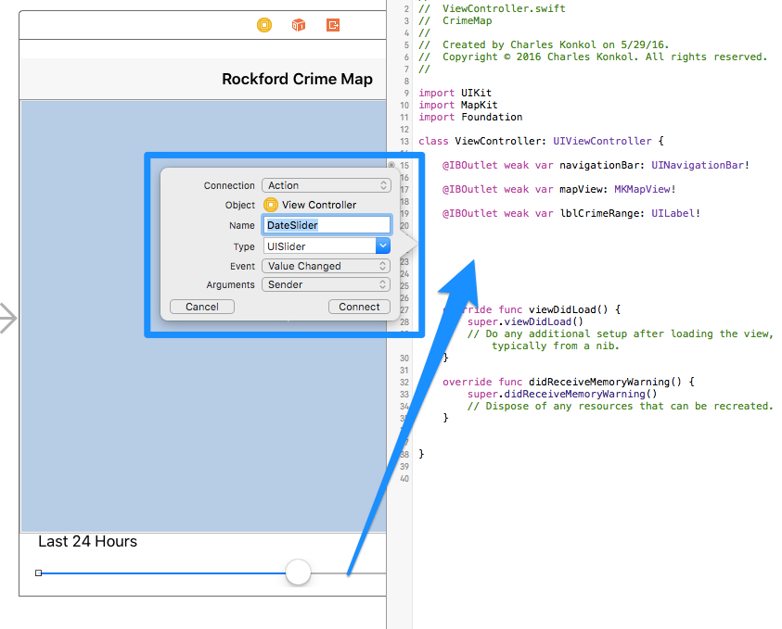
     3. Name: DateSliderUp
        + Touch Up Inside   
            
           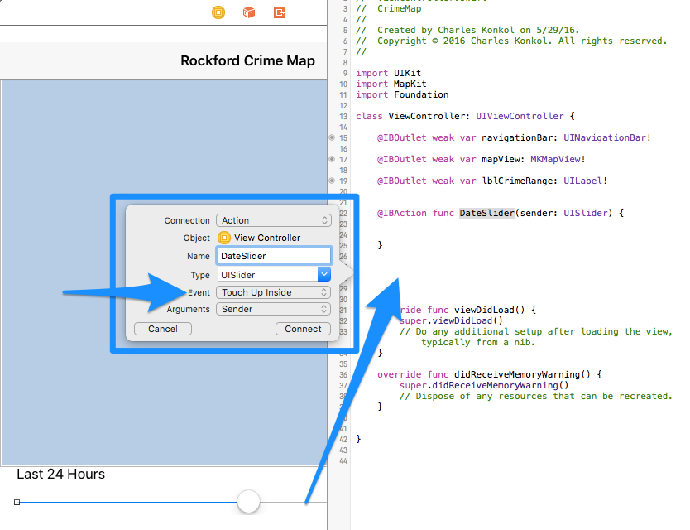
        + 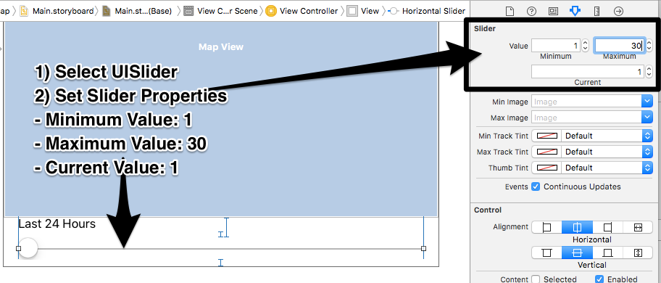
2. Add New Class
   * Control Click on **CrimeMap** folder and select **New File**
   * 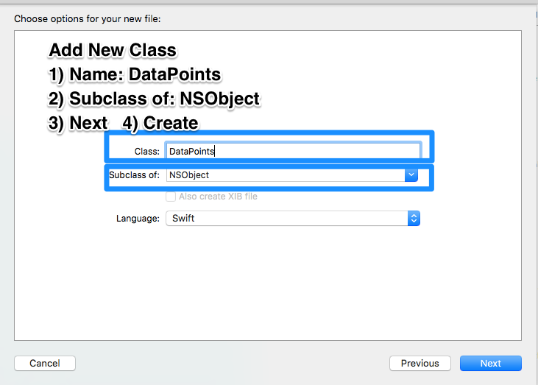
   * Class Name: **DataPoints,** Subclass: **NSObject**, Language: **Swift**
3. Add Code. Follow Steps in Code
   * [ViewController.swift](https://github.com/ioscourse/CrimeMap/blob/master/ViewController.txt)
   * [DataPoints.swift](https://github.com/ioscourse/CrimeMap/blob/master/DataPoints.swift.txt)
4. Align Objects
   * Editor > Resolve Auto Layout Issues > Reset to Suggested Constraints
5. Add Icon
   * User Pixlr.com to create a 1024x1024
   * <https://makeappicon.com/>